Cutting Out Cancer

Many people in today’s society do not know much about cancer prevention and treatment. Most do not know that one in three people contract cancer. Understanding the different preventions and treatments of cancer is essential to living a long and healthy life. Cancer affects all parts of the human race including children, adults, newborns and elderly people. This disease can also affect men and women of any age. There is several different treatment methods involved with fighting cancer. There are also many different types of cancers that affect most parts of the human body.
What is cancer? The Nation Cancer Institute (NCI) notes that “Cancer is the development of abnormal cells that divide uncontrollably. The disease is caused by mutations to DNA within cells.” (“Defining”) Scientific evidence shows that cells are the basic unit of structure and function in life. Cells are constantly growing and reproducing, in some cases the process of reproduction in cells becomes interrupted with a mutation. “A mutation is any change in the original sequence of a DNA strand”. (National Cancer Institute “Defining”) The first known description of human cancer was written by the Egyptians between 3000-1500 BC. The description referred to tumors of the breast. It is important to understand that not all tumors are cancerous. Tumors can be diagnosed as benign or malignant. A benign tumor is not cancerous and therefore is not a threat. These tumors are often removed and do not spread throughout the body. On the contrary, malignant tumors are cancerous. Malignant tumors spread throughout the human body and reproduce the same cancerous cells. “The process by which the cancer spreads to other parts of the body can be defined as metastasis.” (NCI “Origins”) This year approximately 2,140 men were diagnosed with breast cancer and around 230,480 women were diagnosed with the disease. (“Prevention”) It is estimated by the NCI that 1,596,670 cases, excluding melanoma skin cancers, will occur next year. The estimated number of cancer related deaths, excluding melanoma skin cancers, is around 571,950. (“Statistics”) Some symptoms of cancer are obvious but can often be mistaken for something else. Fatigue and weight changes are symptoms of cancer. Lumps that can be felt under the skin are signs of abnormal growths and should be examined. Abnormal changes in pre-existing moles and odd coloring of the skin are symptoms of skin cancers. Difficulty swallowing can be associated with throat and oral cancers. Any consistent abnormal signs or differences to the body and everyday lifestyle should be reported to a doctor or specialist. (Kainoi. Mayoclinic. “Treatments”) Some types of cancers are hereditary which makes family history a cancer prone characteristic. People with light skin and hair are more likely to get skin cancer than those with darker features. (Mayoclinic. “Treatments”)
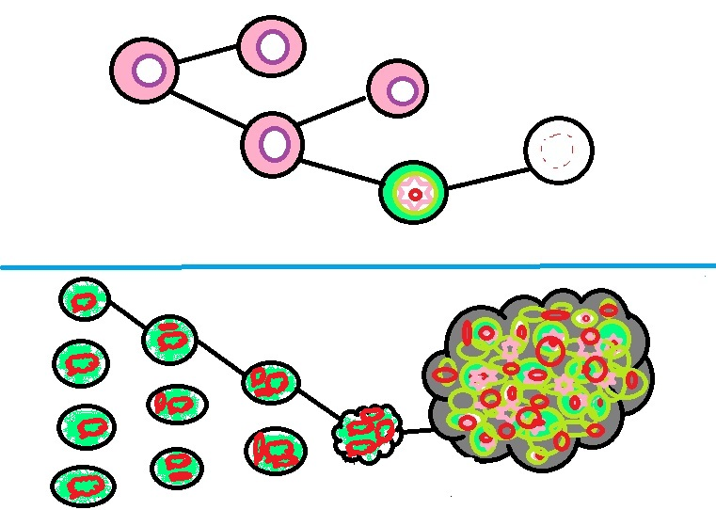
After numerous cell mutations
1
2
3
Cells divide uncontrollably (Cancer)
Cell death/suicide
Non-cancerous cell division
By: Kathleen Paulich
Damage to cell division
Affected cell division
The associate director for communication notes in his article entitled “Cancer Prevention Starts in Childhood,” “The best way to prevent cancer later in life is by adopting a healthy lifestyle while you are young.” The most important pieces of knowledge to obtain about cancer are the ways to help prevent it. Although there are many different forms of cancer there are ways to help avoid the possibility of contracting the disease. Skin cancer is the most common cancer diagnosis; however, it’s also the most preventable. Melanoma is the most dangerous type of skin cancer. To prevent skin cancer it is important to take every precaution. Always wear sunscreen with a high sun protective factor (SPF), somewhere from 45-60 will suffice. It is essential to wear sunglasses and sunscreen that block out both UVA and UVB rays. UVA and UVB are measures of ultra violet rays. A is a long wave while B is a medium wave. These UV waves can be dangerous to the skin. Any exposed skin should also be covered with a hat, shirt, shorts etc... Shady areas are also essential through midday hours. Tanning beds are no better than the suns UV rays. 30 minutes in a tanning bed is the equivalent to an hour in the sun with no protection thus increasing the chances for skin cancers. Yearly mammograms help detect abnormalities fast of the breast tissue, the sooner these abnormalities are detected the better off the health of the patient. Eating healthy, staying active, not smoking, and getting regular screenings are also great preventative actions. Oral and lung cancer are caused mostly by the use of tobacco products, to decrease the chances of contracting oral and lung cancer avoid the use of tobacco products. It is important take not that any form of tobacco can cause oral, mouth, lung and many more types of cancers. Secondhand smoke can also cause lung cancer. In addition, excess exposure to radiation can lead to lung cancer. Children’s lungs are exceptionally weak and when exposed to secondhand smoke, the chances of lung cancer increase rapidly. Exercising for 30-60 minutes a day is essential to maintain a healthy body weight. At age 40 it is important to begin annual mammography screenings. At age 50 men should start being aware of prostate cancer. The Human Papillomavirus , better known as HPV, is passed through sex and is the main cause of cervical cancer. A vaccine is available to prevent most HPV strands that eventually lead to cervical cancer. Getting immunized for Hepatitis B, a virus of the liver, reduces the chances of chronic hepatitis B which can eventually result in cancer of the liver. Steering clear of sharing needles is a sure way to prevent getting hepatitis or other viruses and infections that lead to cancer.
There are plenty of effective treatments available today to help fight the battle of cancer. Research and trials have led treatments to be less toxic today than they were in the past. (Ward. “Reduce”) Clinical trials investigate new ways of treating cancer every day. (Ward. “Reduce”) Taking early detection seriously is the first step to successful treatment. If cancer can be caught in the early stages it is easier to pinpoint where it started and remove all cancerous cells. Stem cell transplants more commonly known as bone marrow transplants are used to treat cancer. The most common treatment options include radiation, surgery, and chemotherapy. Chemotherapy is the use of drugs and hormones to fight cancerous cells. Chemo is most often received in combination with radiation and surgery. There are many different ways chemotherapy can be given. Chemo can be given to a patient in creams, pills, infusions and shots. The job that chemotherapy performs is preventing the continuity of fast growing cells throughout the body. (Kanoi. “Treatments”) Chemotherapy is a very powerful drug that has many negative side effects. While chemo may kill off cancerous cells it often destroys harmless cells resulting in long lasting side effects like hair loss and infertility. Some side effects of chemo are nausea, vomiting and fatigue. Another effective way of treating cancer is radiation therapy. Radiation uses high power x-ray like machines to kill cancer cells. (Kanoi. “Treatments”) Surgery is also used to remove malignant tumors. After surgery it is very common for patients to receive radiation and chemotherapy to destroy any existing cancerous cells. While going through treatment, palliative care is a number one importance in cancer treatment. Palliative care is the promise between a doctor and his or her patient to reduce stress and pain and increase comfortability to the best of the doctor’s ability. There are two main goals when it comes to cancer treatment. The primary goal is to remove the cancer. The secondary goal is to kill and destroy any remaining cancer cells. Some alternative medicines include acupuncture, hypnosis, mediation and massage. These treatments are not proven to successfully remove cancer but are often used for comfort. Hormonal therapy is another alternative in treating cancer. Hormone therapy removes hormones so that cancerous cells can no longer grow and divide. In addition to hormone therapy, biological therapies use the body’s immune system to fight cancer. Immunotherapy’s job is to boost the immune system and increase the body’s defense against the rapid cancerous cell growth.
Some people have a higher chance of being diagnosed with cancer than others. In women, it is more common for a woman who has used birth control pills to be diagnosed with cancer rather than those who have not used birth control pills. Women who are sexually active at a young age are more likely to receive cervical cancer. Breast cancer is also hereditary and men and women with a family history of breast cancer are very likely to be diagnosed with this type of cancer. Breast feeding helps reduce the chances of breast cancer. The highest number of cancer deaths comes from men and women fighting lung cancer. Oral cancers are not only in the mouth but also in the throat. The different stages of cancers are represented by Roman Numerals I-IV, or, 1-4. Some cancer signs and symptoms are clear and obvious. Many people experience fatigue and weight loss/gain. Studies also show that in men, white men are more likely than any other race to be diagnosed with testicular cancer. Testicular cancer is also most common in men whose age ranges from 15-35 years of age. (“Prevention”) It is also important to adopt healthy habits early in childhood. Habits play a large role in causing cancer along with age and family history. (Ward. “Reduce”) Studies show that around 240,890 men will be diagnosed with prostate cancer this year. (Tate. “Prevention”)
In summary, maintaining a healthy diet and exercising daily for a minimum of 60 minutes will help reduce the risk of contracting cancer. Knowing that there are actions to prevent cancer such as wearing hats and covering up the body in the sun also help reduce the risk. Adopting healthy habits while at a younger age to carry on into adulthood is a key way to maintaining a healthy body weight and diet and exercise routine. Understanding the importance of avoiding carcinogens such as, tobacco products and excessive amounts of alcohol, play a key role in cancer prevention. The largest way to prevent contracting cancer is to take all the precautions possible and seeing a doctor regularly. It is important for doctors to know about any abnormalities. Increasing the knowledge possible to obtain about treatments is also important. Knowing that there are many different types of alternative treatments is important as well. Cancer doesn’t discriminate age, color, weight, gender, or height; Cancer can be diagnosed in anybody. Understanding the scientific facts of cancer is also a key tool to helping better comprehend cancer as a whole. In whole the very most important thing to know about cancer is that patients never go through treatment alone. The palliative care of the family and doctors is received 100% through the treatment and prevention stages.
Works Cited
Associate Director Of Communications. "Cancer Prevention Starts in Childhood." Www.Cdc.org. N.p., 02 Mar. 2011. Web. 04 Sept. 2011.
Kainoi, Brian. "Cancer Treatments." Www.Mayoclinic.com. N.p., 18 July 2010. Web. 11 Sept. 2011.
Ward, Kathryn. "Reduce Your Cancer Risk." Www.airc.org. N.p., 24 Aug. 2010. Web. 14 Sept. 2011.
Mihir, Patel. "Reduce Your Cancer Risk." Www.CancerCenter.com. N.p., 16 June 1997. Web. 15 Oct. 2011.
Andrew, Afolobi. "Defining Cancer." Www.CancerCenter.com. N.p., 16 Apr. 2002. Web. 15 Sept. 2011.
Ammanecer, Calle. "Cancer Slideshow Pictures." Www.CancerCenter.com. N.p., 18 Oct. 1995. Web. 23 Oct. 2011.

